

# Test Automation

**Experiment:**

Scraping Images through scrapy

**Submitted by : Submitted to :**

**Akhand Pratap Singh Mr. Alind**

**Step 1**: Activate environment:



**Step 2**: Create a project

Command :- scrapy startproject project_name

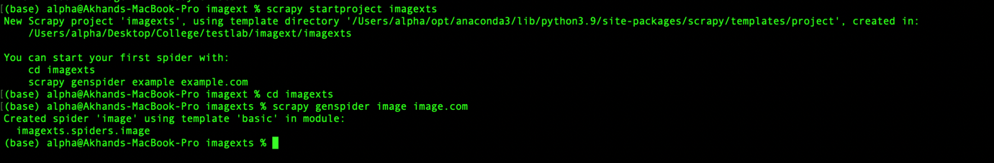

**Step 3**: RUN Command

scrapy genspider image image.com

**Step 4**: Write required code for Scraping Images through scrapy

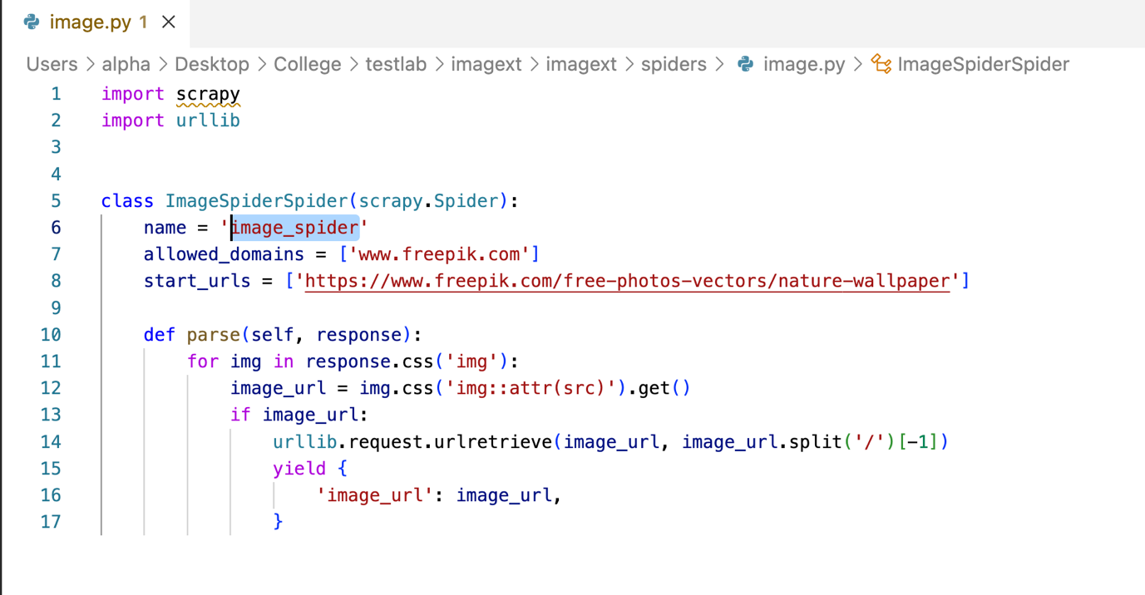

**Step 5**: Run the script

Command : -- crapy crawl image_spider

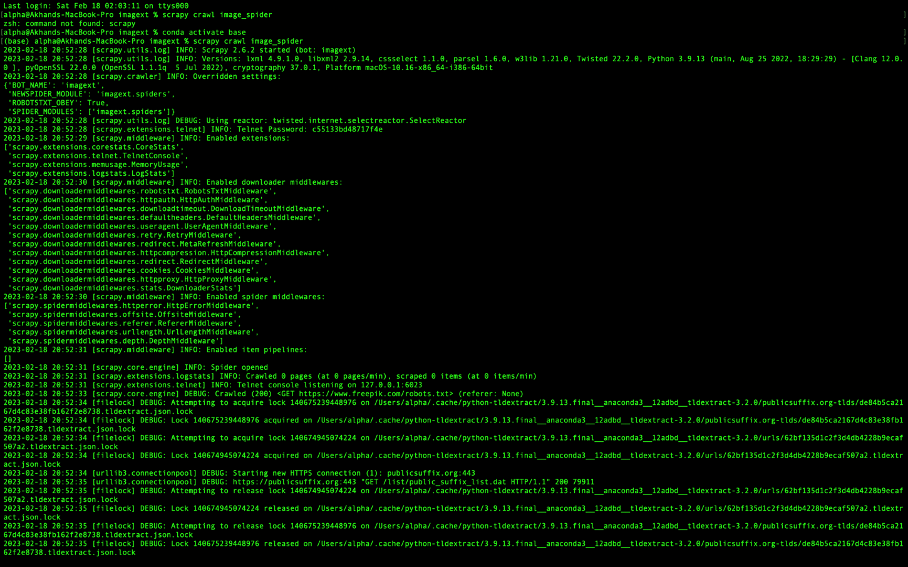

Downloaded image : 